**MEMO**

From: Richard Rennehan, 0413101, IT Data Analytics

To: Bill Cunningham

Date: November 15, 2018

SUBJECT: DBAS3018 ASSIGNMENT 3

# **Statement of Requirement**

The purpose of this memo is to reveal the answers to the 9 Intro to PL/SQL textbook problems and explain the steps taken to get there.

# **Existing Materials**

Screenshots of the textbook problem instructions are provided in the following pages

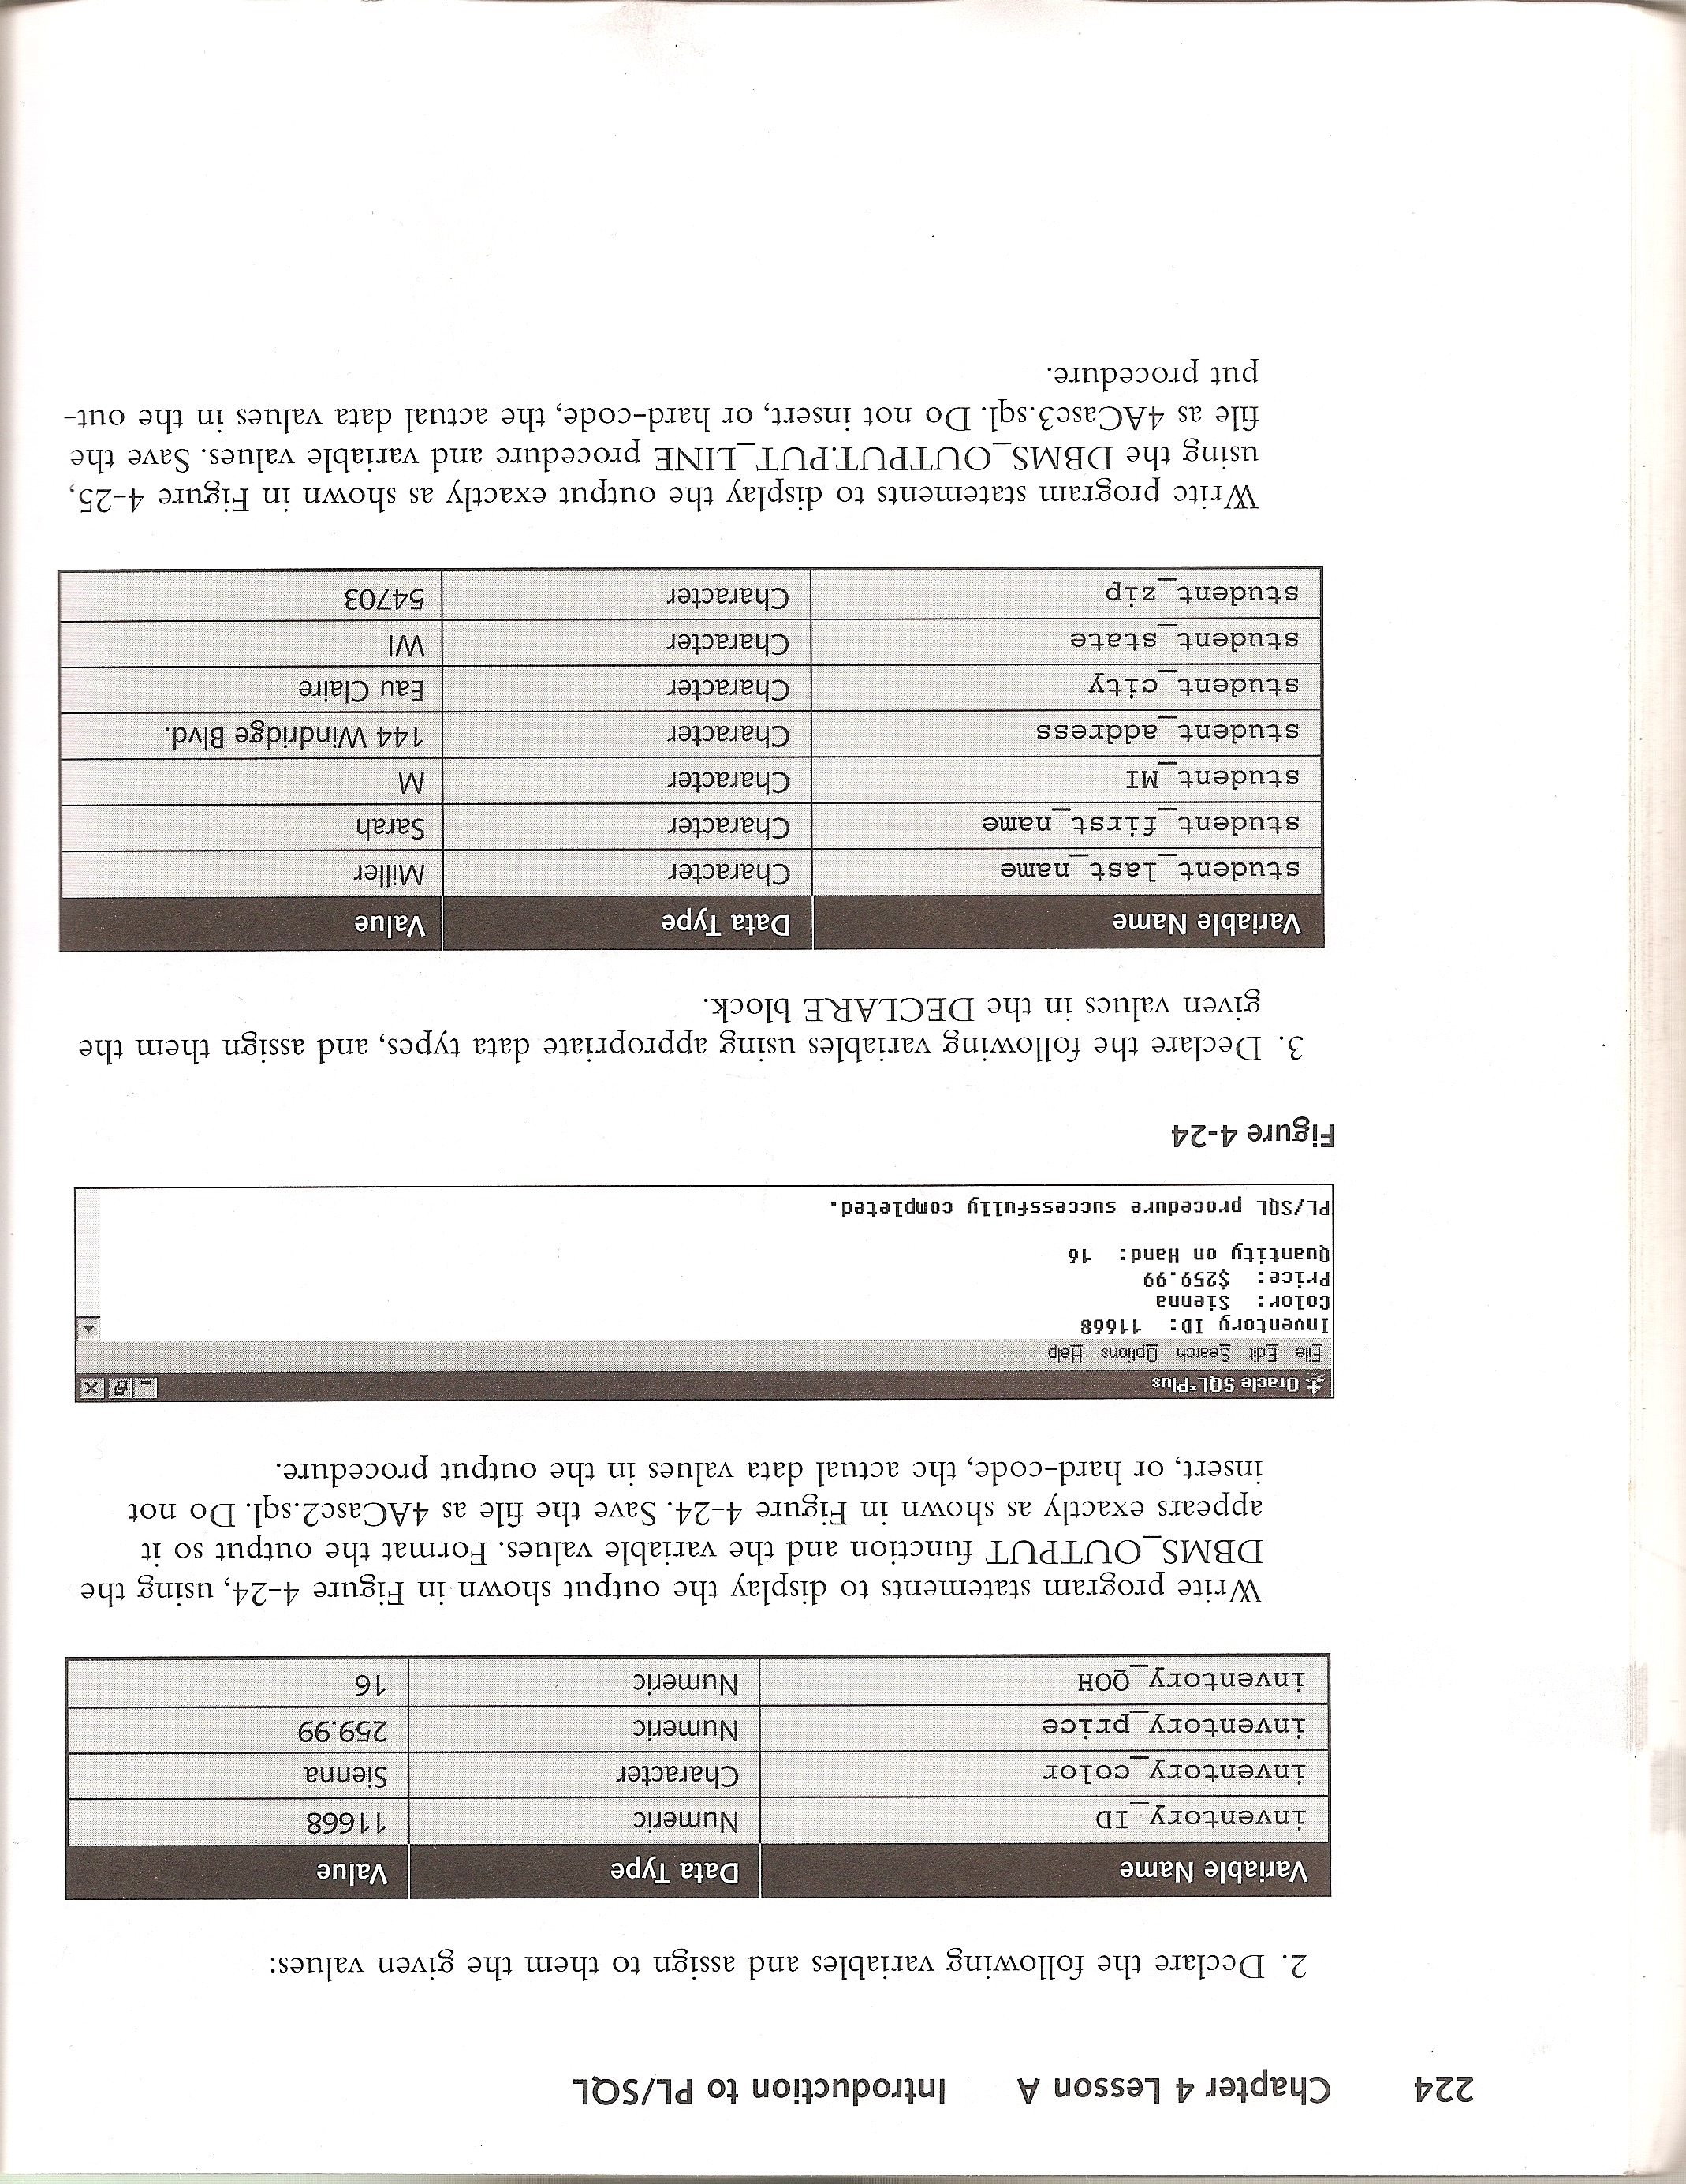

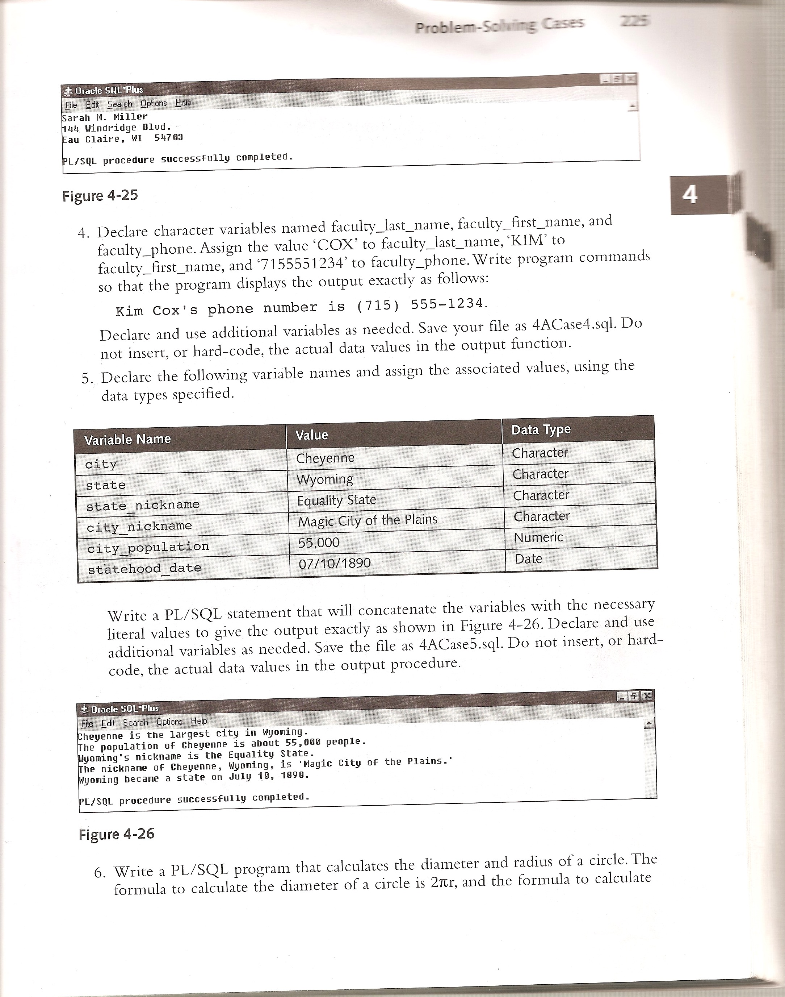

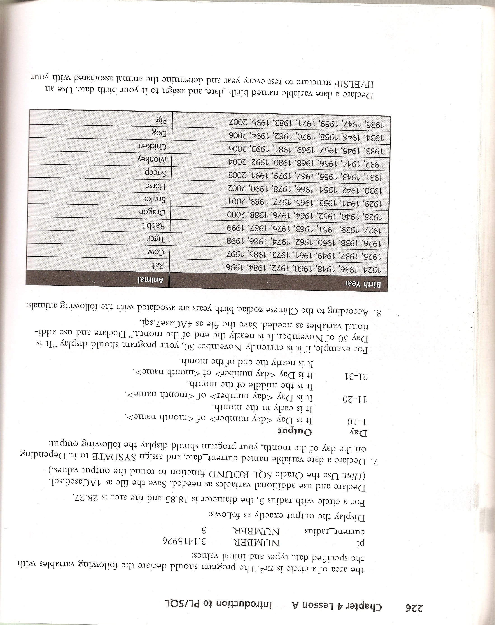

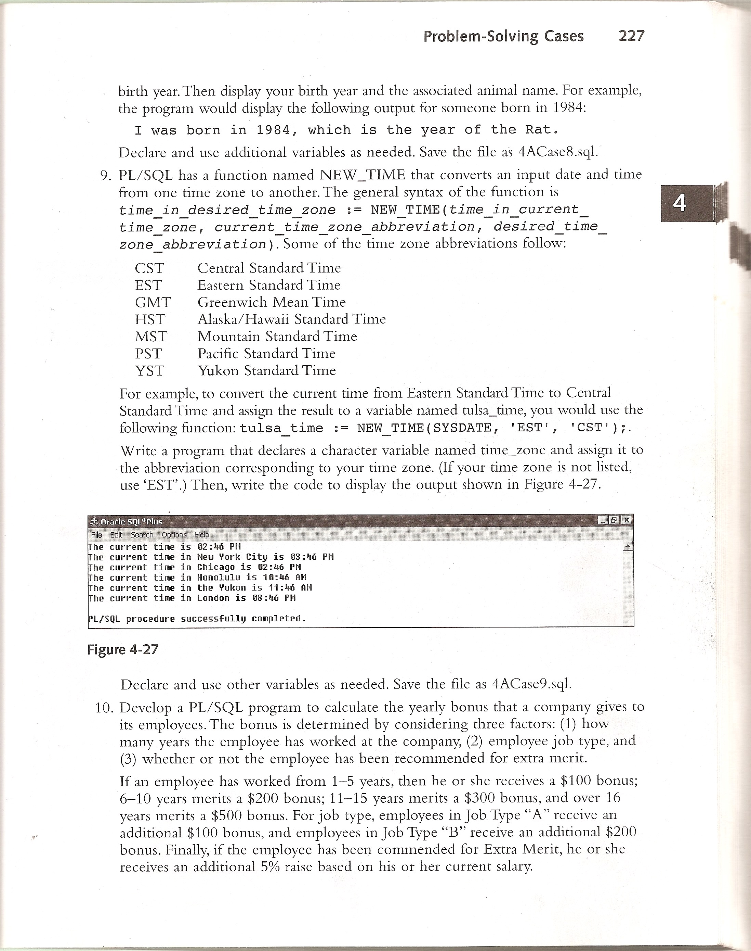

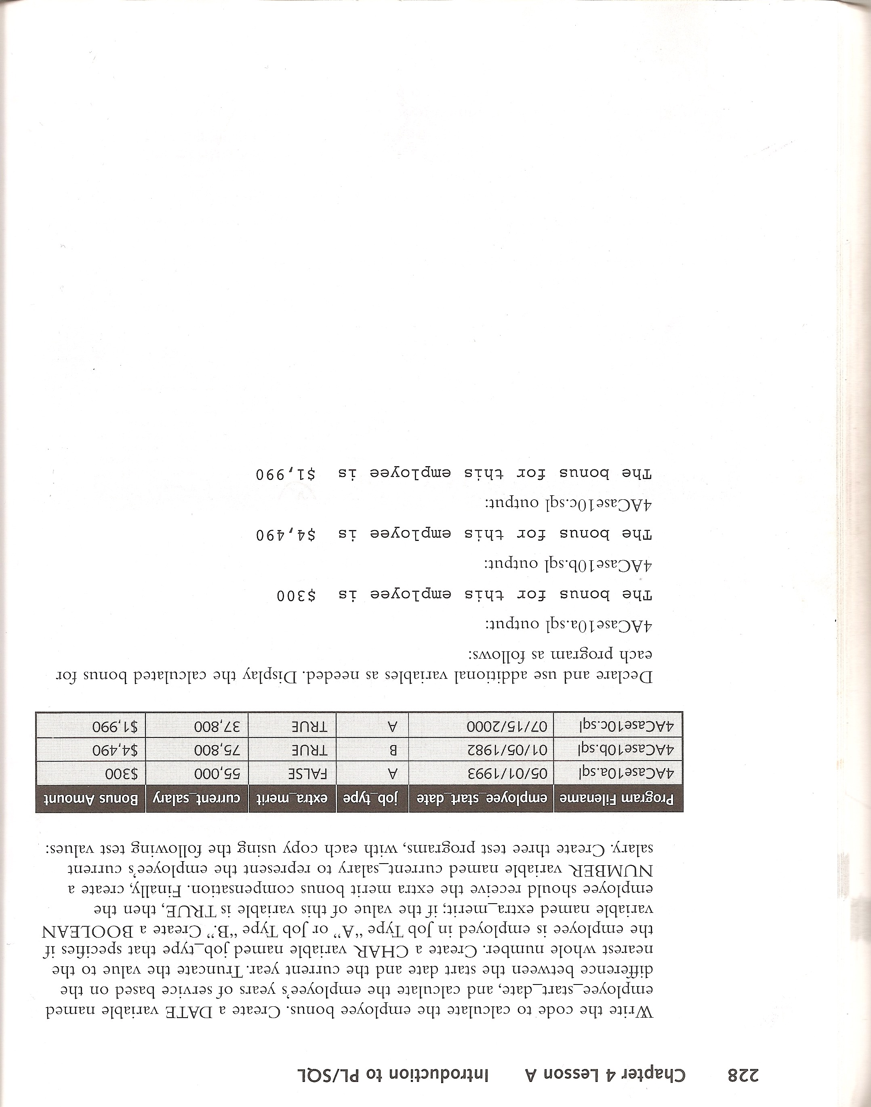

# **Solutions**

The following solutions supply screenshots of the code running and explain the steps taken to get there.

Problem 2.

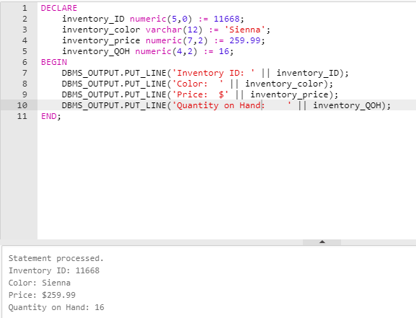

This problem tests your ability to set up a basic PL/SQL block, assign variables, and use concatenation to display messages that are easy to understand.

I always start by immediately writing DECLARE, BEGIN, and END; to split up my PL/SQL block into sections.

As requested, I declared the 4 variables and their datatypes in the DECLARE section of the PL/SQL block. Then, I assigned them the requested values using the := symbol. I was careful to assign the proper datatypes and lengths.

In the BEGIN section, I used DBMS_OUTPUT.PUT_LINE to print each of the 4 lines needed. In each function, I used concatenation with the || symbol to combine the values inside the variables with text strings.

Problem 3.

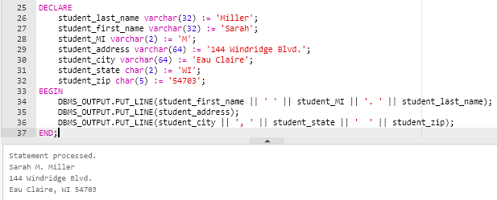

This problem expands on problem 2 with extra variables and more concatenation.

My process was the same as problem 2. I started by writing DECLARE, BEGIN, AND END;. I declared all my variables, their datatype, and their assigned value. Then, I wrote my DBMS_OUTPUT.PUT_LINE functions to print everything needed.

Problem 4.

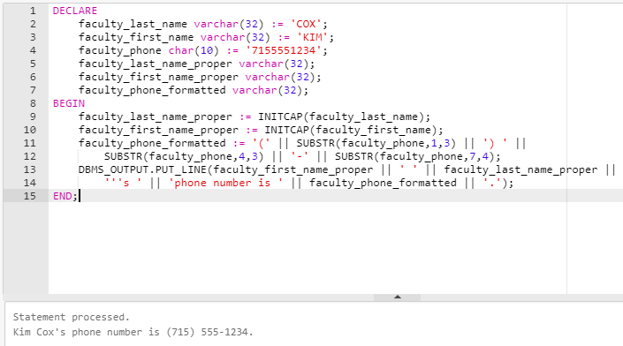

This problem tests your ability to transform original values into new values.

I started declaring the variables and their values. I realized if I wanted to display my result exactly as the textbook, I would need to transform the original values. For example, 7155551234 needed to turn into (715) 555-1234.

I decided to declare new variables that would hold the transformed values. I did not immediately assign a value using := because they are supposed to be empty at the start.

Instead of going straight to DBMS_OUTPUT.PUT_LINE, I started the BEGIN section by setting my values for the transformed versions of the variables. I used INITCAP to turn the names from all caps to proper-case. I used the SUBSTR function and concatenation to turn the phone number into the desired format. With this, I was able to print the whole result using a quick DBMS_OUTPUT.PUT_LINE

This is also the first time where I had to insert an apostrophe in a string. I learned that in a string, you need two apostrophe marks touching to print one apostrophe. Let’s look at '''s', for example. The first mark is to start the string. The second mark and third mark combined is turned into the apostrophe when printed. The fourth mark by itself is used to conclude the string. The process is to start by writing 's', then put the two additional apostrophe marks before the s.

Problem 5.

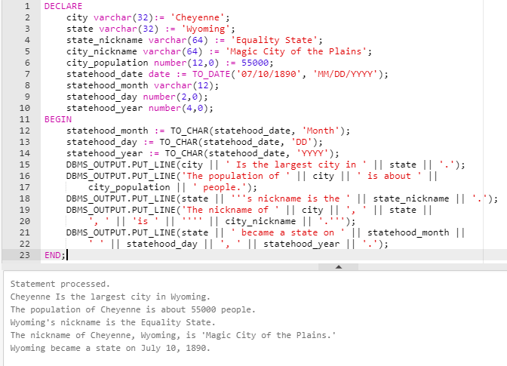

This problem tests your ability to work with dates in PL/SQL.

I declared statehood_date using date as the datatype. To ensure it was stored in the desired date format, I used the TO_DATE function. I stored it as MM/DD/YYYY.

In the BEGIN section, I started by separating the whole date into three separate variables for month, day, and year. I used the TO_CHAR function to accomplish this, which pulled out the value requested from the whole date. I continued like normal using the skills I have learned so far.

Problem 6.

Note that the textbook confuses diameter for circumference. 2πr equals circumference rather than diameter. All instances of diameter are replaced by circumference.

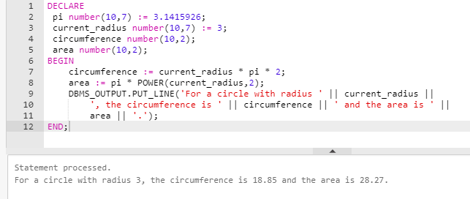

This problem tests your ability to apply mathematics to PL/SQL blocks.

I declared the required variables as number datatypes, ensuring that I allowed for plenty of space after the decimal as needed. I declared additional variables to store the circumference and area once they were calculated. I intentionally limited the spaces for circumference and area to 2 so they would be formatted like in the textbook.

In the BEGIN section, I immediately proceeded to calculating the circumference and area. The circumference was as easy as multiply each value together using the * symbol. For area, I called upon the help of the POWER function, which allowed me to square the radius. The rest of the situation used the same printing and concatenating abilities I am familiar with.

Problem 7.

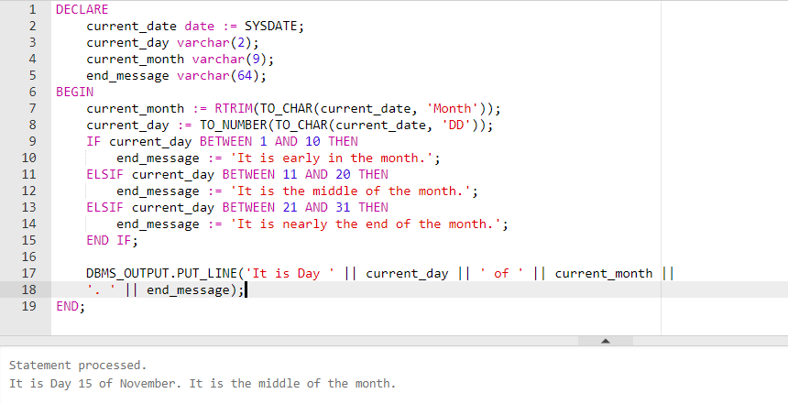

This problem tests your ability to use IF structures in PL/SQL blocks. It also extends working with dates

When I first used TO_CHAR(current_date, ‘Month’), I discovered it would print extra spaces after the month. After some research, I discovered that getting month from TO_CHAR will always fill in blank spaces until the month reaches 9 characters. I removed the extra spaces by wrapping the whole function in RTRIM().

This also marked my first time using TO_NUMBER. Because I would have to do number comparisons, I needed to make sure the day was extracted as a number and not a string. Therefore, I wrapped the TO_CHAR function for current_day within a TO_NUMBER() function.

Instead of making three different DBMS_OUPUT.PRINT_LINE functions for each scenario, I decided it would be more efficient to make an additional variable which holds the ending message instead. The IF and ELSIF statements determine which message to use based on the day of the month. I checked the range by using BETWEEN

When making IF, ELSIF, and ELSE structures in PL/SQL, don’t forget to put END IF; at the end.

Problem 8.

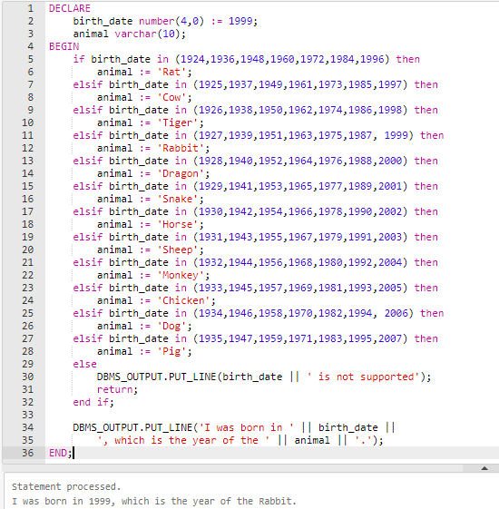

Problem 8 is an extensive test for if and else structures in PL/SQL.

I grouped each of the years with their own if or else statement by using the IN function. The program finds which group your birthyear is in and supplies the correct animal.

If the year the user entered is not included, the program jumps to the else statement. Here, it prints a message stating the year is not supported before immediately quitting the PL/SQL block early using the return clause.

Problem 9.

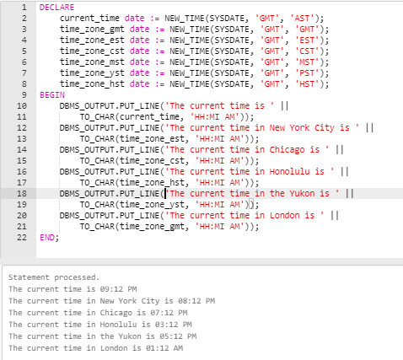

Problem 9 tested the ability to work with time zones, convert times, and display times in the proper format.

After plenty of research and experimentation, I discovered that the best way is to store each variable as a date format rather than a varchar and convert it into a char format at the end using TO_CHAR.

SYSDATE is the simplest way to get the current date and time. Oracle LiveSQL uses GMT time by default for SYSDATE, so when using the NEW_TIME function, I always placed GMT as the first time zone abbreviation. The second abbreviation in the NEW_TIME function is the time zone to convert to. I live in the AST time zone, so I set the current time variable to Atlantic Standard Time. By repeating this process over for each time zone abbreviation, I was able to make variables containing whole date times for each time zone needed.

The thing left was to convert the entire date into the HH:MI AM/PM format (example 12:01 AM). Using TO_CHAR, I discovered that the string needed was ‘HH:MI AM’. I continued to use DBMS_OUTPUT.PUT_LINE and TO_CHAR for each time zone to print all current times in the 12-hour format as requested by the textbook.

Problem 10.

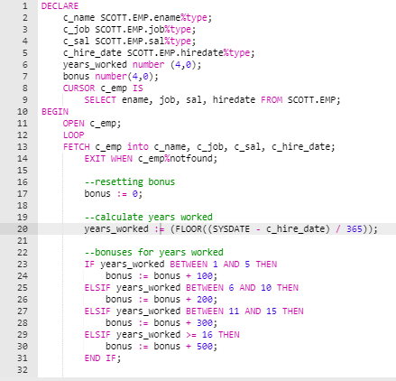

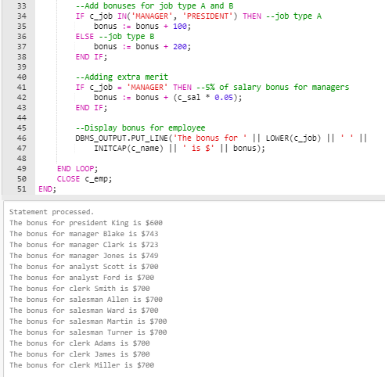

Problem 10 was a final test of PL/SQL skills. It was a culmination of all the skills I have learned from problems 2-9 plus a few new skills as well. Instead of using the provided example in the textbook, I used LiveSQL’s SCOTT.EMP table to challenge myself.

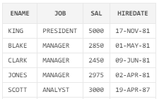

Figure 1: Sample of rows and columns from SCOTT.EMP

Problem 10 was immediately different because the variables would need to store different values at different times. This meant I would have to use either SELECT INTO or a cursor. Because I knew I would be working with multiple rows, I decided to use a cursor.

Using a cursor would allow me to go through each employee one at a time and calculate their bonus before moving onto the next employee. Creating a cursor was as simple as declaring a select statement as a cursor within the DECLARE section. This also meant I would have to make extra variables for the employee’s name, job, salary, and hire date. These variables temporarily store values from the employee table. To ensure the datatypes from the table and the new variables match up, I declared the variables as the %type.

In the BEGIN section, I started by opening the cursor. Then, to set up the loop through each employee, I placed my LOOP and END LOOP; statements. Between the two is the fetch statement. The fetch statement is the key to transferring the values of the current employee in the loop to the proper variables. To complete the basic structure, I made sure to write: *EXIT WHEN c_emp%notfound;*. This allows the loop to exit when there are no more employees left.

My first step was to calculate the years the employee has worked. I did this by subtracting their hire date from SYSDATE and dividing the result by 365 to get the difference in years. To ensure the value always rounded down, I wrapped the whole thing in a FLOOR function.

I proceeded with my IF statements. Each would check a certain factor of the employee to determine how much to add to their bonus. For example, managers would receive an extra 5% of their salary as a bonus, but this 5% bonus does not apply to any other jobs. One of the IF checks was to see if the current employee was a manager and if so, it added 5% of their salary to their bonus.

By the end of the current loop, the bonus would be tallied up. Each loop concludes by printing the employee’s name, their job, and the bonus they have received.

It’s important to reset the bonus to 0 after each loop. That way, the bonus does not carry on to the next employee.